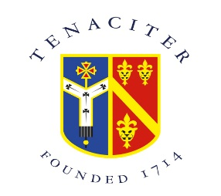

Careers Policy

Archbishop Tenison’s Church of England High School Careers Guidance Policy is currently being updated.
Our Careers Guidance contact is Jess Caplehorne and she can be contacted by email at office@archten.croydon.sch.uk

